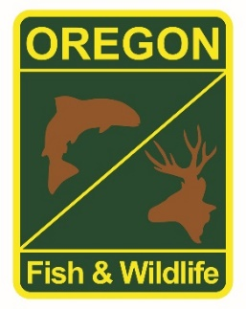

**State Fisheries Genomics Lab Tissue Sample Intake Form**

Please complete the top part of this form and send to: [kathleen.omalley@oregonstate.edu](mailto:kathleen.omalley@oregonstate.edu)

Make arrangements with us prior to dropping off the tissue samples and include a copy of this form with your samples.

**Project dropping off samples:**

ODFW Willamette Valley Hatcheries

**Person dropping off samples:**

**Phone: Email:**

541-757-5228 ryan.b.couture@state.or.us

**Description of samples (e.g. species, collection locations, collection dates, collection methods, number of samples, life stage; may attach spreadsheet):**

Mckenzie River Spring Chinook adults.

HOR CHS collected at Mckenzie and released above Trailbridge and Cougar (includes data sheets) and HOR spanwers in batch samples

**If applicable, known origin (e.g. natural or hatchery):**

NOR - included in broodstock

HOR- spawned for brood and released above Trailbridge and Cougar

**Sample type (e.g. fin tissue, scale, muscle, etc):**

Fin tissue

**Storage method (e.g. dry, 95% ethanol, RNA later, etc):**

95% ethanol